**LAPORAN TUGAS**

**PEMROGRAMAN BERBASIS OBJEK**

*Laporan ini disusun untuk memenuhi tugas mata kuliah Teori Pemroqraman Bebasis Objek*

**

Disusun oleh:

Nurul Anisah 211511052

**PROGRAM STUDI D3 TEKNIK INFORMATIKA**

**JURUSAN TEKNIK KOMPUTER DAN INFORMATIKA**

**POLITEKNIK NEGERI BANDUNG**

**2021**

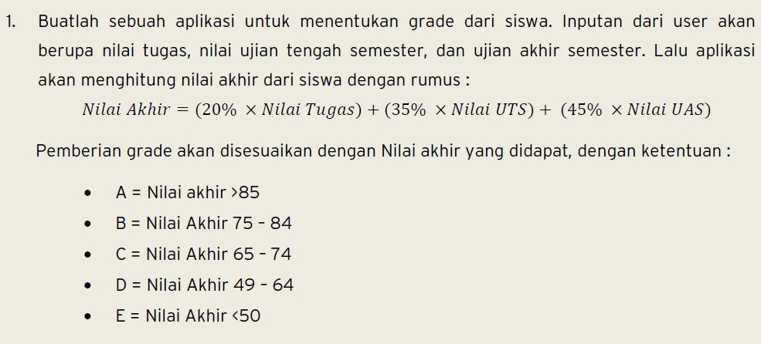

Jawaban :

**package** pboTeori;

**import** java.util.Scanner;

**public** **class** tugas1 {

/**

* **@param** args the command line arguments

*/

**public** **static** **void** main(String[] args) {

**final** **double** NT, NETS, NEAS, NA;

String Result = **null**;

Scanner Scan = **new** Scanner(System.***in***);

System.***out***.println("App Nilai Akhir");

System.***out***.print("Masukan Nilai Tugas : ");

NT = Scan.nextInt();

System.***out***.print("Masukan Nilai ETS : ");

NETS = Scan.nextInt();

System.***out***.print("Masukan Nilai EAS : ");

NEAS = Scan.nextInt();

NA = (0.20 * NT + 0.35 * NETS + 0.45 * NEAS);

**if**(NA >= 85 && NA <= 100) {

Result = "A";

} **else** **if**(NA >= 75 && NA <= 84) {

Result = "B";

} **else** **if**(NA >= 65 && NA <= 74) {

Result = "C";

} **else** **if**(NA >= 49 && NA <= 64) {

Result = "D";

} **else** **if**(NA >= 0 && NA <= 50) {

Result = "E";

} **else** {

System.***out***.println("Nilai mustahil terwujud");

}

System.***out***.println("Selamat anda mendapatkan nilai akhir " + Result);

}

}

Outputnya

